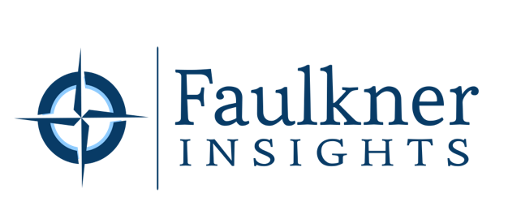

FOR IMMEDIATE RELEASE Contact: Sarah Faulkner, Owner, Faulkner Insights
Phone: +1.859.240.0200
Email: Sarah@FaulknerInsights.com

Faulkner Strategic Consulting Announces Rebrand
The new brand, Faulkner Insights, better encapsulates core values offered to clients.

Cincinnati, OH, August 26, 2021 – Faulkner Insights, a consultancy focused on consumer insights for innovation, announced today that it has completed a rebranding effort from its previous name, Faulkner Strategic Consulting. While strategic consulting remains a core service, the substitution of Insights in the name better reflects the consultancy’s main value to clients—deep consumer and market insights that drive innovation to grow brands.

Faulkner Insights was originally founded in 2014 by Sarah Faulkner, an insights consultant with over 21 years of global research and strategy experience across multiple industries—from Fortune 50 companies to fast-growing startups. Prior to founding Faulkner Insights, she spent 14 years at Procter and Gamble working on consumer insights for major brands such as Pantene, Olay, and Gillette as well as corporate innovation.

“One of the hardest things in business is to stop doing something that seems to be working now, in favor of something that will help you win in the future,” said Sarah Faulkner, Owner of Faulkner Insights. “We are making this name change to focus on what matters most to our clients—the insights they get to drive innovation and grow their business.”

About Faulkner Insights
Faulkner Insights is a strategic consultancy focused on insight-driven innovation and brand-building. They provide custom research solutions to uncover deep human insights and find actionable stories in data. For additional information, please visit www.FaulknerInsights.com

###

If you would like more information, please contact Sarah Faulkner at Sarah@FaulknerInsights.com or (859) 240-0200.

